PressureLens: A Pressure-Aware Mixed Reality Intelligent Paper Reading Assistant

Final Project Summary Report — CSci 488/688 Human–Computer Interaction
Student:Wei Wang
Project Type: Individual Project

1. Implemented Tasks
PressureLens is an MR-based paper-reading assistant that augments physical documents with OCR and LLM-generated explanations. All implemented tasks are shown below.

Task T1 — Capture Paper Document & Start Reading
Purpose:
Allow users to place a paper document under the iPad (via Osmo mirror) and start reading with real-time camera capture.
Features:
- Automatic perspective correction
- Manual adjustment sliders for expert users
- Shows system status “Video Ready / OCR Ready”
- Prevents user from proceeding until OCR is complete
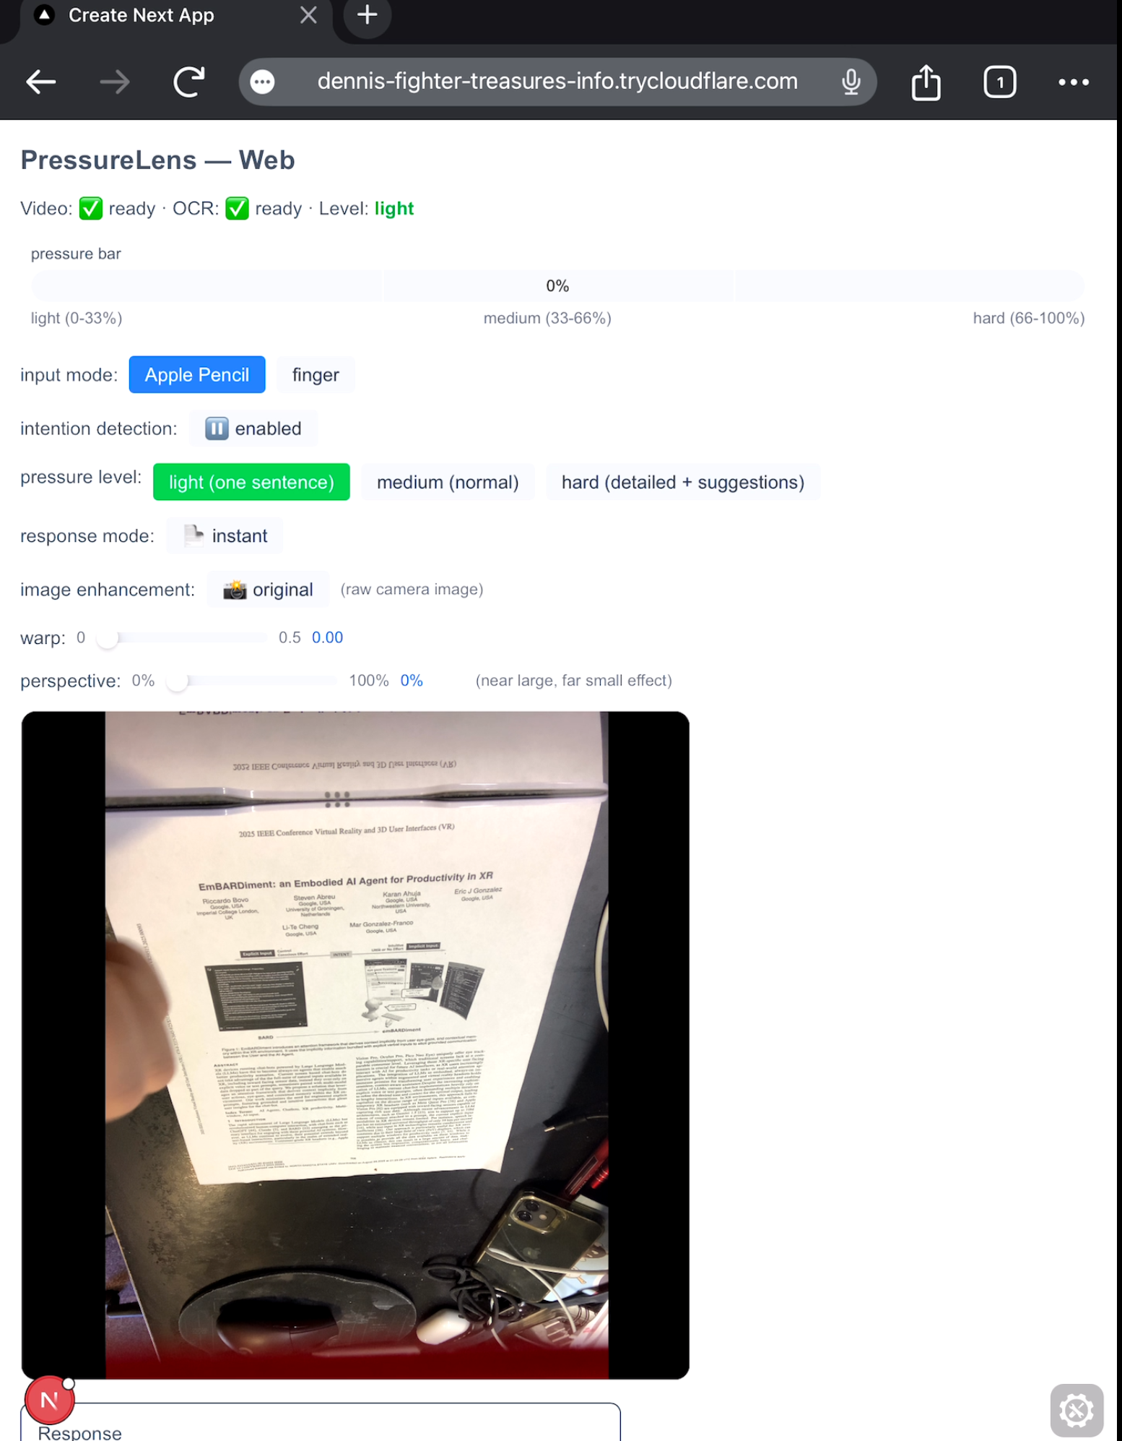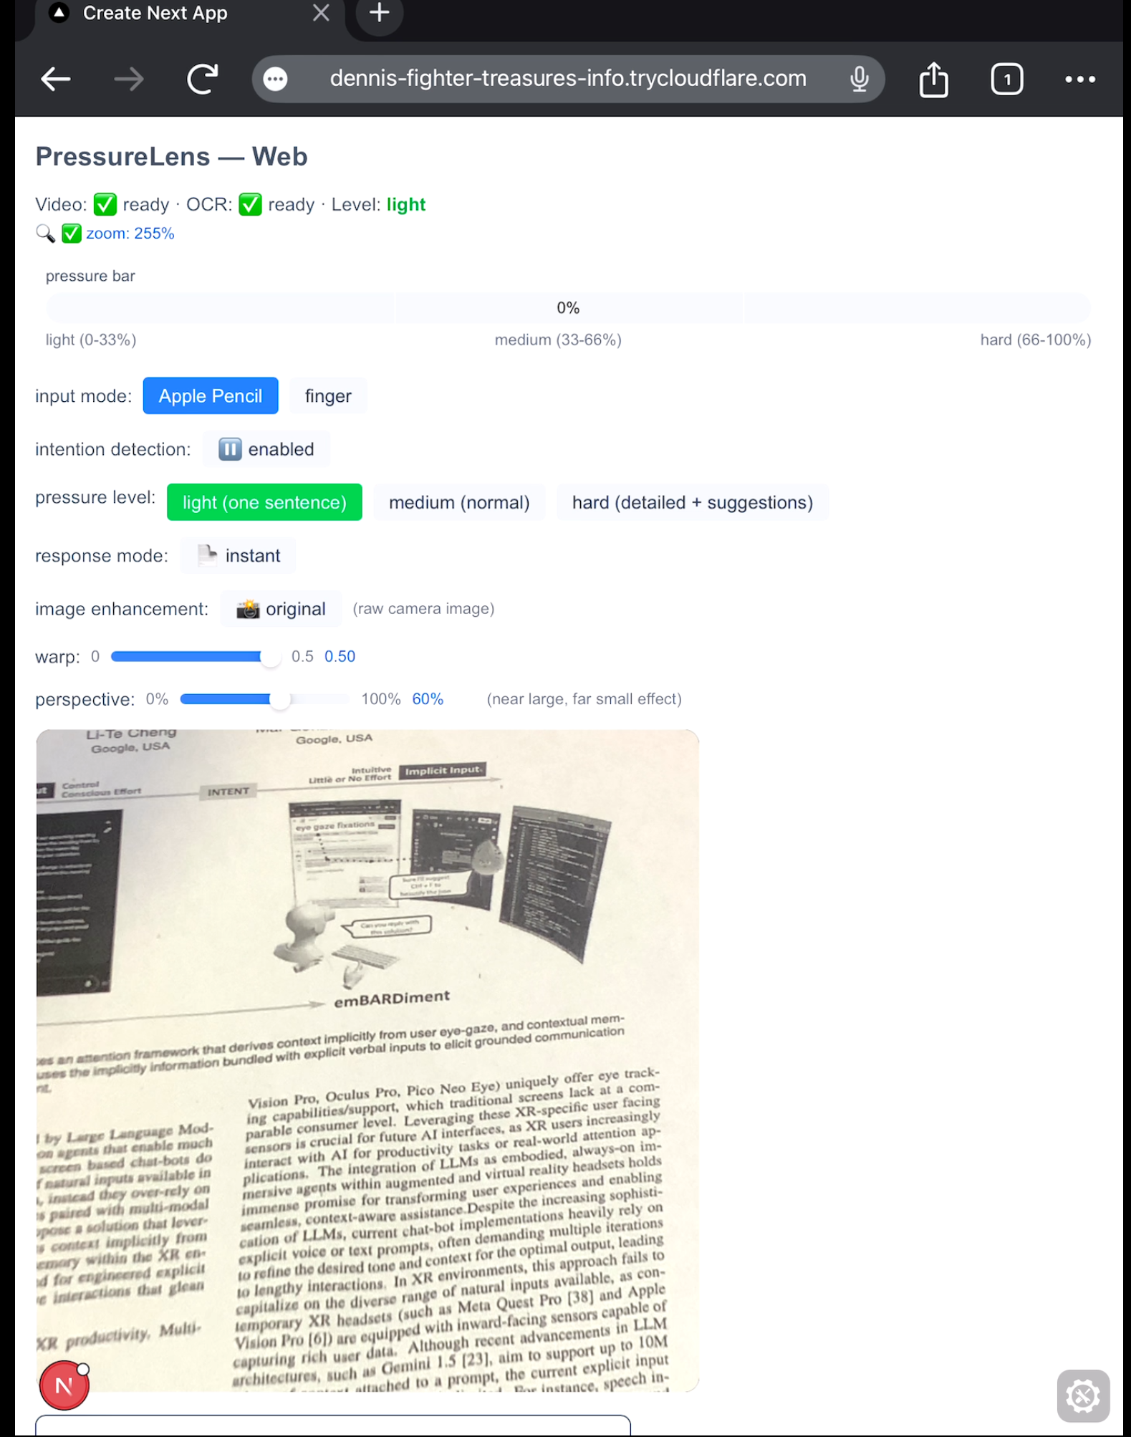
T1

Task T2 — Finger-Tracing Interaction
Purpose:
Enable natural finger-reading on physical paper.
When the user's finger holds still, the system infers request.
Features:
- MediaPipe hand tracking
- Halo indicator around fingertip
- Timer visualizes “hold” duration (longer = deeper explanation)
- Short tap ignored (< 1800ms) to prevent accidental triggers
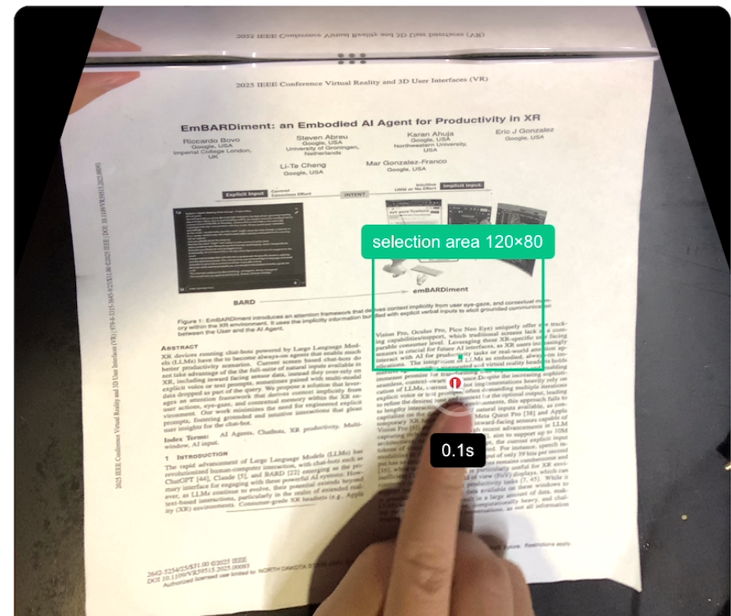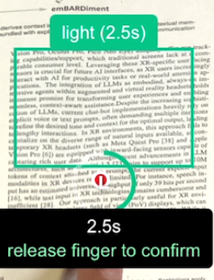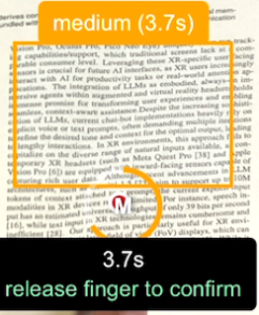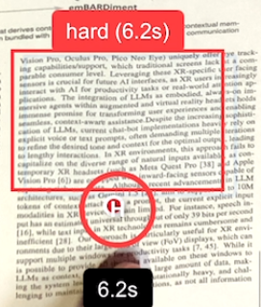
- T2

Task T3 — Apple Pencil Region Selection & Pressure-Based Commands
Purpose:
Allow precise selection of text or diagrams using Apple Pencil.
Features:
- Users circle a region to select OCR text
- Real-time pressure meter (green→yellow→red gradient)
- Pressure depth maps to explanation depth
  - Light press → brief summary
  - Medium press → contextual explanation
  - Deep press → full detailed interpretation

Task T4 — AI Explanation Overlay (AR Feedback)
Purpose:
Display AI-generated results directly on top of the paper view without interrupting reading.
Features:
- Floating draggable cards in AR view
- Bounding boxes highlighting selected content
- Cards can be dismissed or repositioned freely
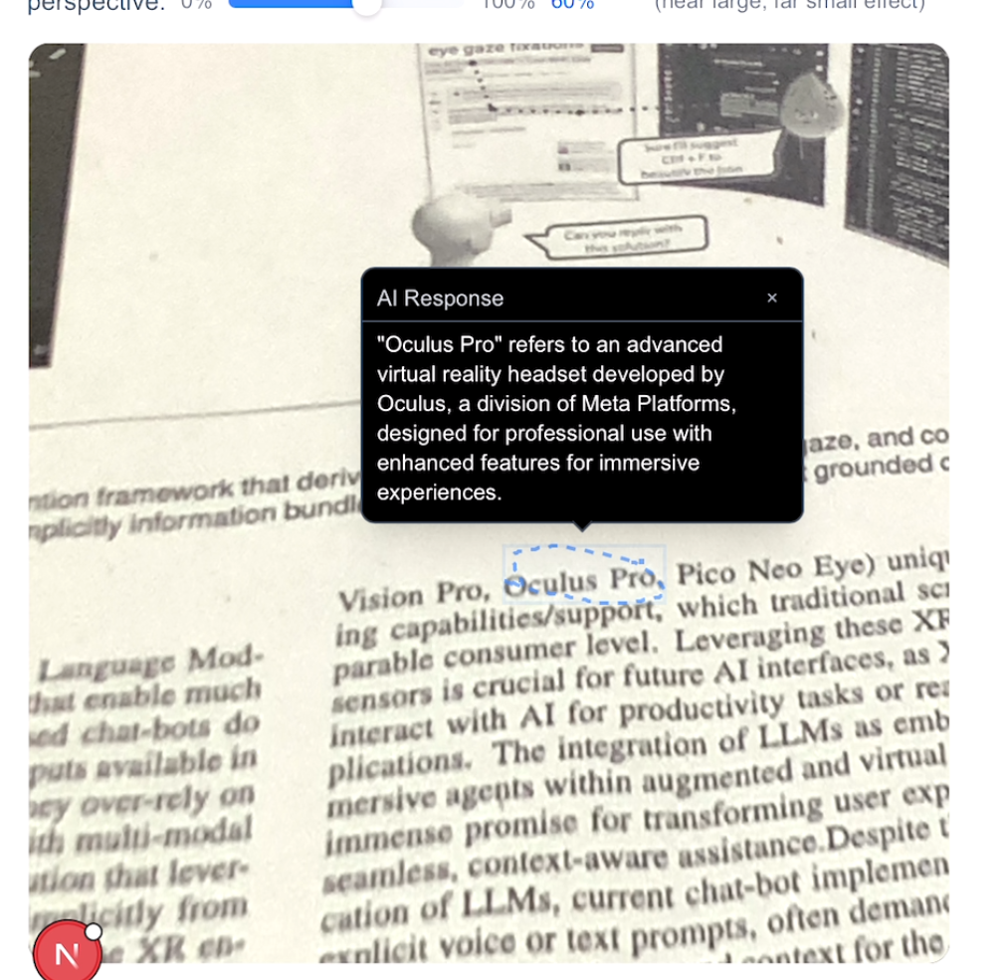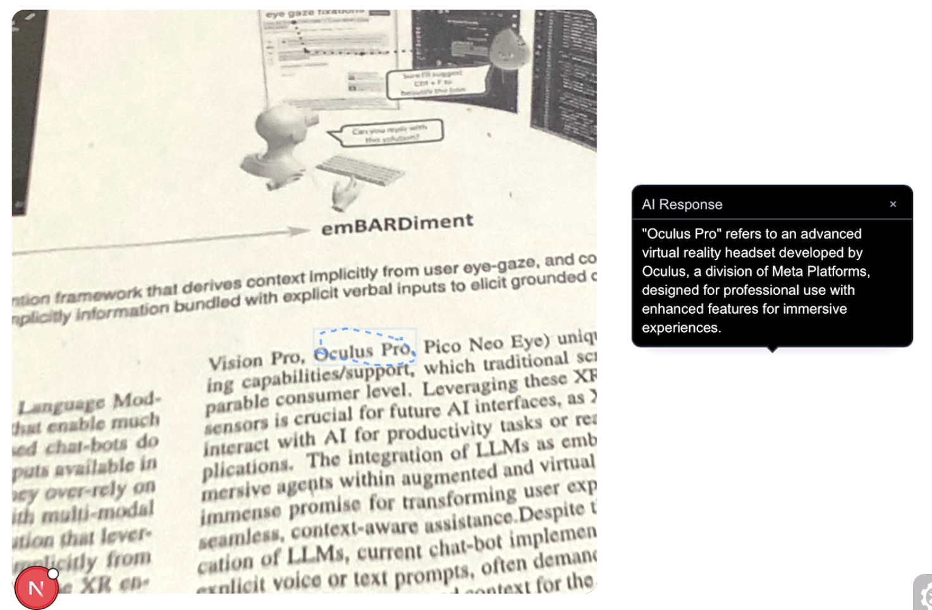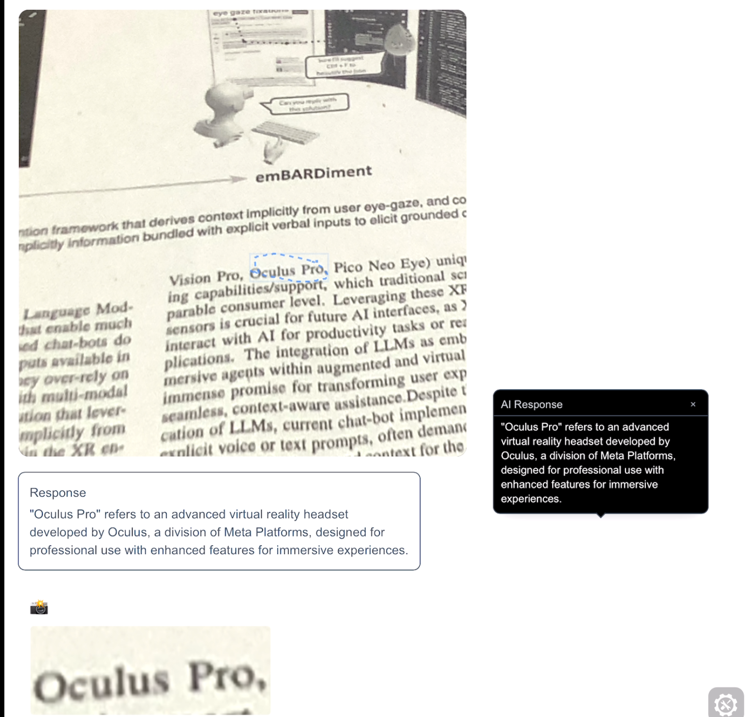

T3-T4

2. Storyboard: Switching Between Tasks
Below is a storyboard showing how a user transitions between tasks.
Step 1 — Launch PressureLens
User set up device and opens the webpage; camera feed activates through Osmo mirror.
Step 2 — System Performs Perspective Correction
Automatic correction with preset value + manual sliders available.
Step 3 — Begin Reading (T1)
OCR status changes to Ready. User sees live-aligned bounding boxes.
Step 4 — Finger Tracing (T2)
Finger halo appears → hold triggers explanation.
Step 5 — Pencil Interaction (T3)
User circles region → pressure display rises with force.
Step 6 — AI Explanation Overlay Appears (T4)
Floating card aligned with paper; user drags it aside to continue reading.
Step 7 — Continue Reading / Switch Tasks
User can freely switch between finger(T2 T4), Pencil(T3 T4) interaction.
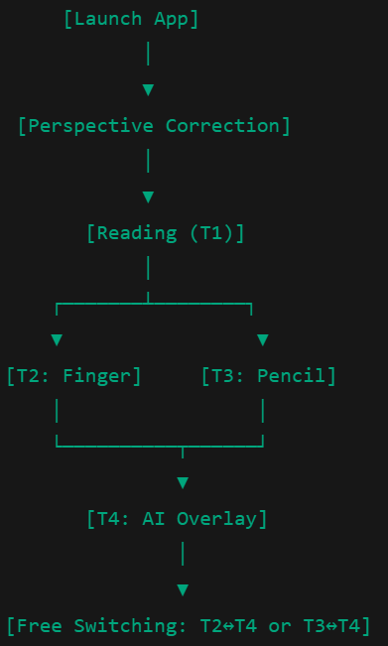

3. Detection Algorithms
3.1 OCR Algorithm (Tesseract.js)
The OCR module extracts text from user-selected regions so that LLM explanations can be generated.
PressureLens uses Tesseract.js, a browser-based OCR engine based on the LSTM sequence recognition model in Google Tesseract 4.
Step 1 — Image preprocessing
To improve recognition accuracy under real-world lighting conditions:
- Perspective correction
  - This compensates for the angled camera view caused by the mirror.
  - The top edge of the captured region is treated as a rotation axis.
  - The image is then rotated in 3D space until the top and bottom edges become approximately equal in width.
- Vertical stretching
  - Slightly adjusts the region’s aspect ratio to ensure characters are not too compressed vertically after correction.

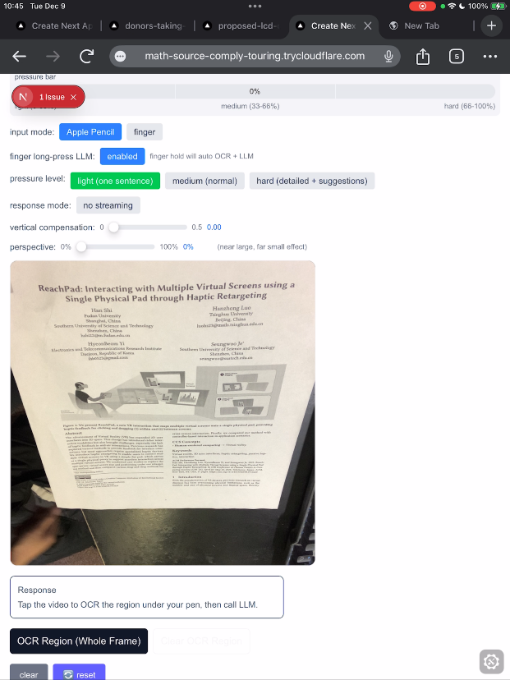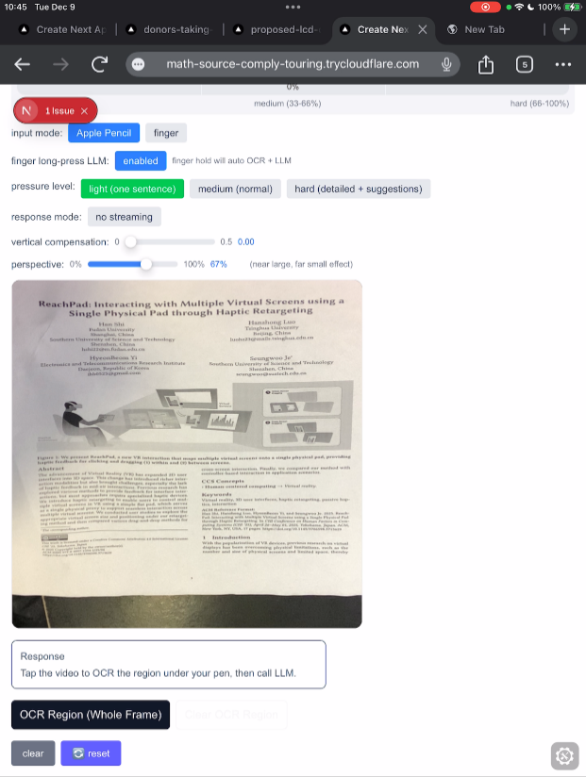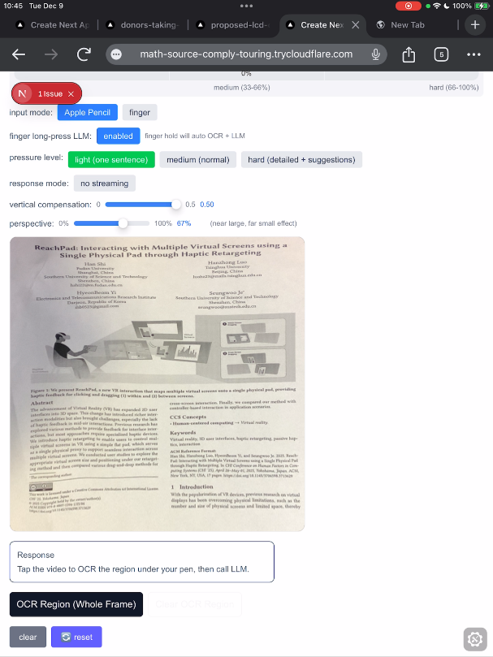
Original(left), Perspective correction(center), Perspective correction +Vertical stretching(right)

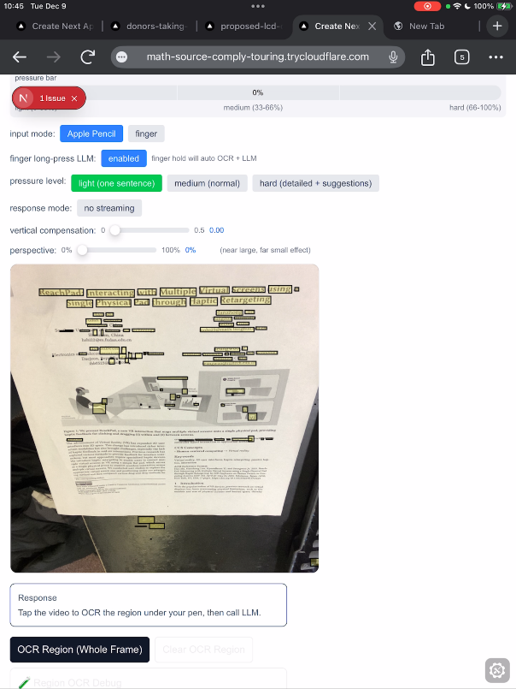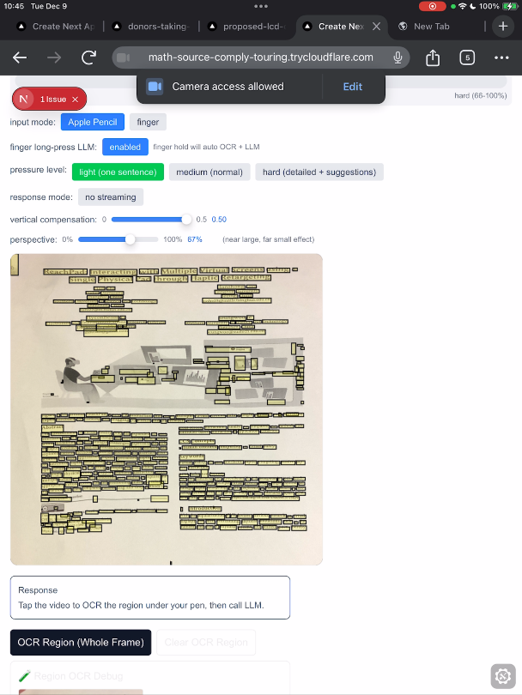

Step 2 — Capture region from camera feed
- The selected polygon ( Pencil input) is cropped from the live camera frame produced through the Osmo mirror.
Step 3 — Run OCR via Tesseract.js
The corrected region is passed directly into Tesseract.js for text recognition. PressureLens does not implement its own OCR model; instead, it relies entirely on Tesseract.js’s built-in deep learning pipeline.
Internally, Tesseract.js performs operations such as:
- Text line segmentation
- Character probability prediction (using Tesseract’s LSTM-based model)
- CTC(Connectionist Temporal Classification) decoding to generate the final text string
These steps are handled automatically by the library. From the system’s perspective, OCR is triggered simply by calling:
const result = await Tesseract.recognize(imageRegion, 'eng');
The output includes:
- The recognized text
- Word-level bounding boxes
- Confidence values
PressureLens uses this text with high confidence for generating LLM prompts.

3.2 Finger Tracing Detection ( MediaPipe Hands)
This module enables natural interaction while reading. PressureLens uses MediaPipe Hands to track finger movement and infer user interest.
MediaPipe Hands is a two-stage deep learning architecture designed for fast and accurate 3D hand landmark detection. It achieves real-time performance (~30–60 FPS) even on mobile devices.
Stage 1 — BlazePalm: Hand Detection Network
BlazePalm is a lightweight CNN-based region-proposal network optimized for palm detection.
Features:
- Anchor-based bounding box regression
- Super-fast inference (<1–2 ms per frame)
- High recall rate for small and partially occluded hands
- Produces a palm bounding box as the region of interest (ROI)
This stage dramatically reduces computation because the second stage only processes cropped hand regions.
Stage 2 — Hand Landmark Model
After cropping the ROI, a second deep neural network predicts 21 keypoints per hand.
Architecture characteristics:
- Multi-layer CNN with residual blocks
- Regresses 3D coordinates (x, y, z)
- Robust against motion blur, lighting changes, and low-resolution input
- Predicts fingertips, knuckles, and wrist joints
These landmarks form a skeletal representation of the hand.
In our system, the fingertip of the index finger is obtained, corresponding to landmark #8 in the MediaPipe skeleton.
I use a hold-based detection strategy functionally equivalent to a speed threshold. When the finger first touches or hovers over the paper, the system records both startTime and startPosition. For every subsequent frame, the distance between the new fingertip position and the recorded start position is measured. If the displacement remains within a small tolerance (<15 px), the system interprets this as “the finger is essentially not moving.”
Explanation depth increases with the hold duration:
- Short hold(1.8s-3s) → brief summary
- Medium hold(3s-5.5s) → normal explanation
- Long hold(>5.5s) → detailed explanation

Pompt design
The prompting strategy is interaction-adaptive. Finger mode requests an explanation of the cropped region above the fingertip with increasing detail based on hold duration, while Pencil mode uses the extracted text as the explicit query. This ensures accurate, context-aware AI responses without requiring the system to infer the user’s exact target word.
Unlike the Pencil interaction (precise bounding circle), finger interaction crops a larger rectangular area around the fingertip for OCR and interpretation. When generating explanations from finger-based selection, the system inserts instructions into the prompt.
The LLM is explicitly told:"This image is a cropped region directly above the user's fingertip.Please analyze or explain the text contained in this cropped region, if any. If the image contains no meaningful text, simply describe what is visible."

4. Detection Accuracy Evaluation
Finger Hold Detection
- 30 hold tests(10 per level)
- Correct detection rate: 93%
Pencil Pressure Levels
- 30 trials (10 per level)
- Accuracy: 100%

5. Citations
- Tesseract.js OCR Library: https://tesseract.projectnaptha.com/
- OpenAI GPT-4o-mini API: https://platform.openai.com/docs/models/gpt-4o-mini
- MediaPipe Hands Tracking: https://ai.google.dev/edge/mediapipe/solutions/vision/hand_landmarker
- Apple Pencil Pressure APIs: https://developer.apple.com/documentation/uikit/handling-input-from-apple-pencil

